Breast Cancer Detection and classification from Mammogram images based on  
GMM Segmentation and GLCM-DWT feature extraction and PNN  
Classification  
Under the Guidance of  
DR. NIRMALYA GHOSH  
Assistant Professor, Department of Electrical Engineering, IIT Kharagpur, India

PRABIR KUMAR DAS SHIVANI SINGH  
Roll – 20MM62R02 Roll - 20MM61R10  
M-Tech in Medical Imaging and Informatics M-Tech in Biomedical Engineering

Mammography is the basic screening test for breast cancer. It consists many artefacts, which negatively influences in detection of the breast cancer. Therefore, removing artefacts and enhancing the image quality is a required process in Computer Aided Diagnosis (CAD) system. The accuracy and efficiency of the CAD is increased by providing exact Region of Interest (ROI). Extracting ROI is a challenging task in pre-processing because the presence of pectoral muscle influences the detection of abnormality. Here, the proposed show that the wiener filter and Contrast Limited Adaptive Histogram Equalization (CLAHE) techniques efficiently aids for enhancing the quality of the image, thereby it also removes the unwanted  
background and the pectoral muscle by using thresholding and modified region growing technique respectively.

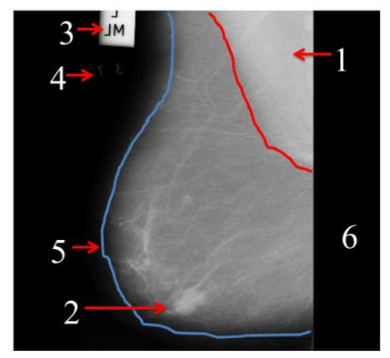

The main purpose of a breast cancer CAD system is to help the radiologist and doctors to take decision swiftly. By providing exact ROI will help to identify abnormality. The proposed method works in three stages as explained in figure 2. The first step is to remove the back ground artefacts (label 3,4 and 6) identified in the figure 1.The second step is to  
reduce the pectoral muscle (label 1) identified in figure 1 and the digital mammography enhanced by using wiener filter and CLAHE.

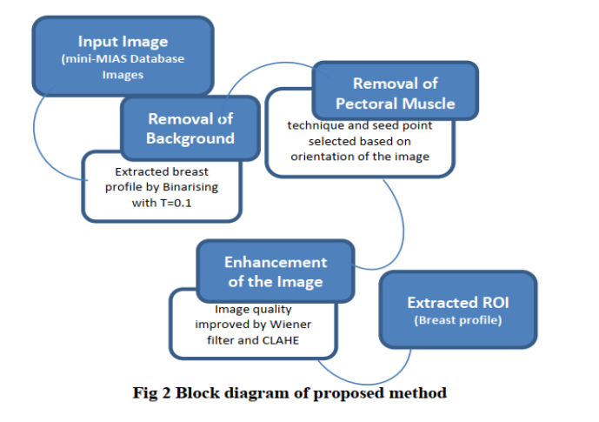

**Background Removal**Initially image was binarized with threshold value 0.1 then the connected component organized in descending order to extract the largest blob which is the breast profile but consists of pectoral muscle.  
**Suppression of pectoral muscle**The second stage was used to reduce the pectoral muscle part by using modified region growing technique. The seeded region growing is one of the image segmentation methods, it works in two ways based on selected pixel locational value and other is selection of seed point. The seed point may be selected adaptively or manually. In the proposed method,  
seed point is selected automatically by considering the orientation of the mammography. This approach determines the neighbouring pixels of seed point and examines whether the next pixels should be added to the region or not. The process is iterated till to extract the complete ROI.  
**Image enhancement**Third stage was used to enhance the quality of the image using wiener filter and CLAHE.

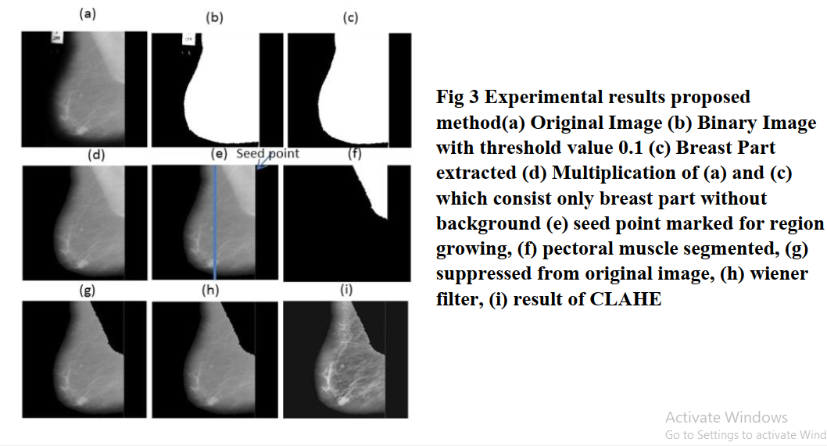

CODE

clc;

clear all;

close all

%% Image display

i=imread('mdb107.pgm');

figure(1)

imshow(i);title('Original Image')

% if image is rgb

try

i=rgb2gray(i);

end

%% Crop The Breast

z=im2bw(i,0.1);

figure(2)

imshow(z);title('Original B&W')

info=regionprops(z);

a=cat(1,info.Area);

[m,l]=max(a);

X=info(l).Centroid;

bw2=bwselect(z,X(1),X(2),8);

i=immultiply(i,bw2);

figure(3)

imshow(i);

title('Getting the Breast and Muscle')

%% Deleting Black Ground

% We will delete the black corners

% So that we can select the muscle

% using bwselect

% convert to B&W first time

[x,y]=size(z);

tst1=zeros(x,y);

% detect empty rows

r1=[];

m=1;

for j=1:x

if z(j,:)==tst1(j,:)

r1(m)=j;

m=m+1;

end

end

% detect empty columns

r2=[];

m=1;

for j=1:y

if z(:,j)==tst1(:,j)

r2(m)=j;

m=m+1;

end

end

% Deleting

i(:,r2)=[];

i(r1,:)=[];

figure(4)

imshow(i);title('after deleting background');

%% Deleting the Muscle

if i(1,1)~=0

c=3;

r=3;

else

r=3;

c=size(i,2)-3;

end

z2=im2bw(i,0.5);

bw3=bwselect(z2,c,r,8);

bw3=~bw3;

ratio=min(sum(bw3)/sum(z2));

if ratio>=1

i=immultiply(i,bw3);

else

z2=im2bw(i,0.75);

bw3=bwselect(z2,c,r,8);

ratio2=min(sum(bw3)/sum(z2));

if round(ratio2)==0

lvl=graythresh(i);

z2=im2bw(i,1.75*lvl);

bw3=bwselect(z2,c,r,8);

bw3=~bw3;

i=immultiply(i,bw3);

else

bw3=~bw3;

i=immultiply(i,bw3);

end

end

figure(5)

imshow(i)

title('Getting only the Breast')

%% Weiner Filter

% We will create average mask [3 3]

% with SNR = 0.2

mask=fspecial('average',[3 3]);

SNR=0.2;

i=deconvwnr(i,mask,SNR);

figure(6)

imshow(i)

title('Weiner Filter')

%% Clahe Filter

i=adapthisteq(i);

figure(7)

imshow(i)

title('Clahe Filter')

RESULTS

